**BIOINFORMATICS ASSIGNMENT 1 (Day 1 - 5)**

***Note: You will be added in a slack community of Bversity for further doubts and communications***

1. Gene Name: SRY (homo sapiens)

2. Function of the Gene: It is the sex determining region. This protein is the testis-determining factor (TDF), which initiates male sex determination. Mutations in this gene give rise to XY females with gonadal dysgenesis, translocation of part of the Y chromosome containing this gene to the X chromosome causes XX male syndrome. The SRY gene is found on the Y chromosome. This protein is involved in male-typical sex development, which usually follows a certain pattern based on an individual's chromosomes.

3. NCBI accession number: NC_000024.10

4. Forward Primer: AGAGTGAAGCGACCCATGAA

5. Reverse primer: TCTCTGTGCATGGCCTGTAA

6. Features of primers: length- 20, GC content- 50%, Tm- 59

7. Amplicon length and sequence: 191,

AGAGTGAAGCGACCCATGAACGCATTCATCGTGTGGTCTCGCGATCA

GAGGCGCAAGATGGCTCTAGAGAATCCCAGAATGCGAAACTCAGAGATCAGCAAGCAGCT

GGGATACCAGTGGAAAATGCTTACTGAAGCCGAAAAATGGCCATTCTTCCAGGAGGCACA

GAAATTACAGGCCATGCACAGAGA

**qPCR Data analysis (DAY 5)**

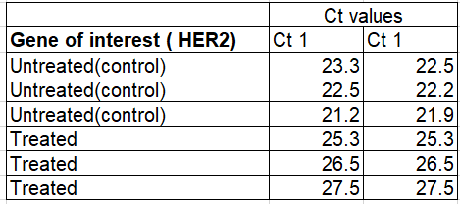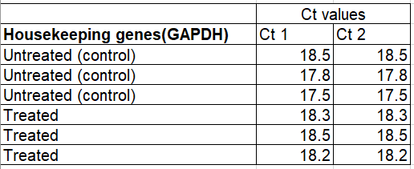

The following data are results of qPCR from cancer cell lines. HER2 stands for human epidermal growth factor. It’s healthy in normal amounts, but too much may be a sign of a certain type of breast cancer. Calculate the 2 Delta Ct values for the following data and plot the values on a graph using graphpad prism.

